CSE494 – Software Project Management
Name: Mr. Aoun Haider, Muhammad Talha Shafique
ID: FA21-BSE-133, FA21-BSE-152
Assignment: 04
Submitted to: Ms. Humaira Afzal
CLO:<03>;Bloom Taxonomy Level:<Applying>
Task 1: Adjust task duration after altering finish date
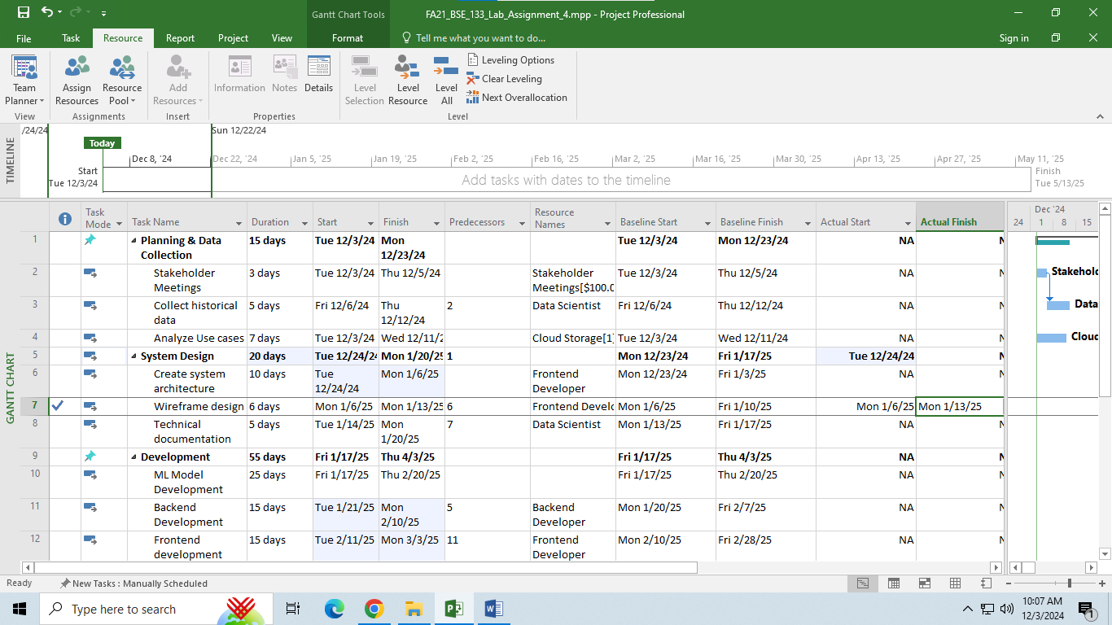

Task 2: Increase Cloud storage by 100$ and observe cost variance
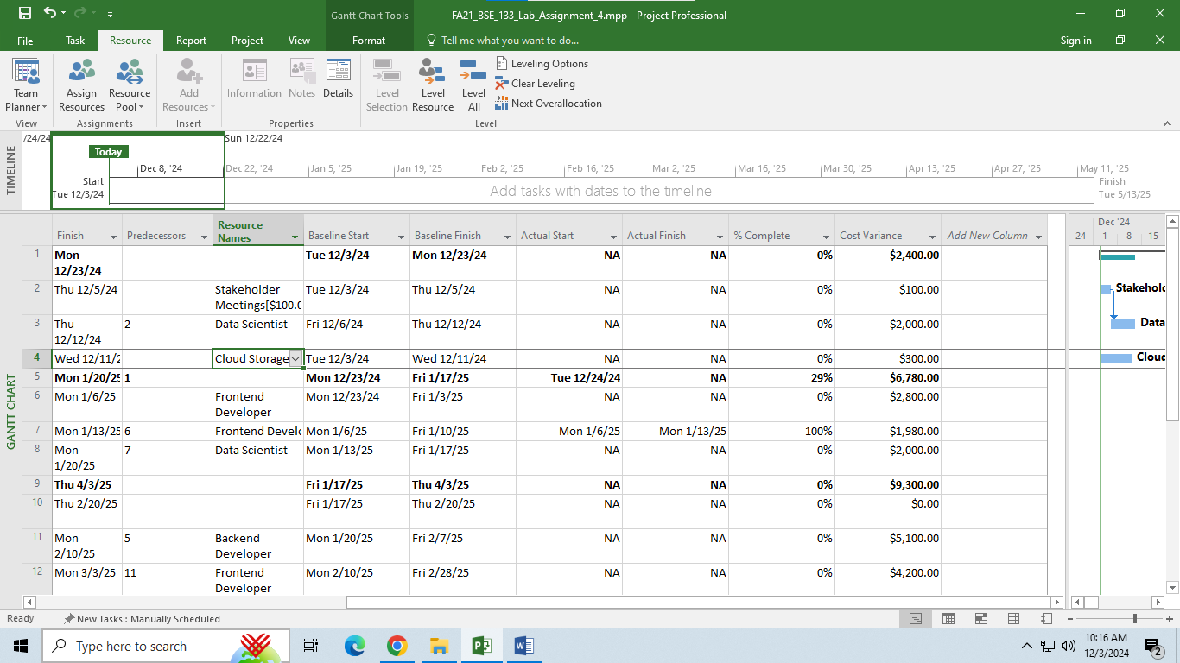

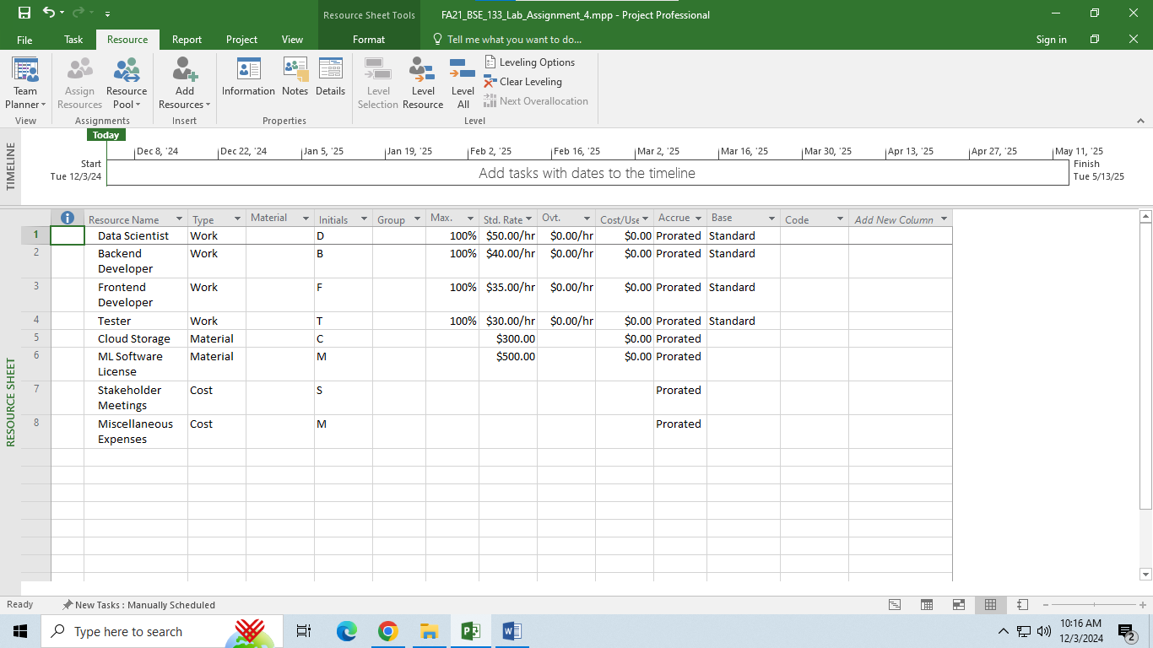

Task 3: Adjust task dependencies
Interpretation: Dates are changed after removing dependency
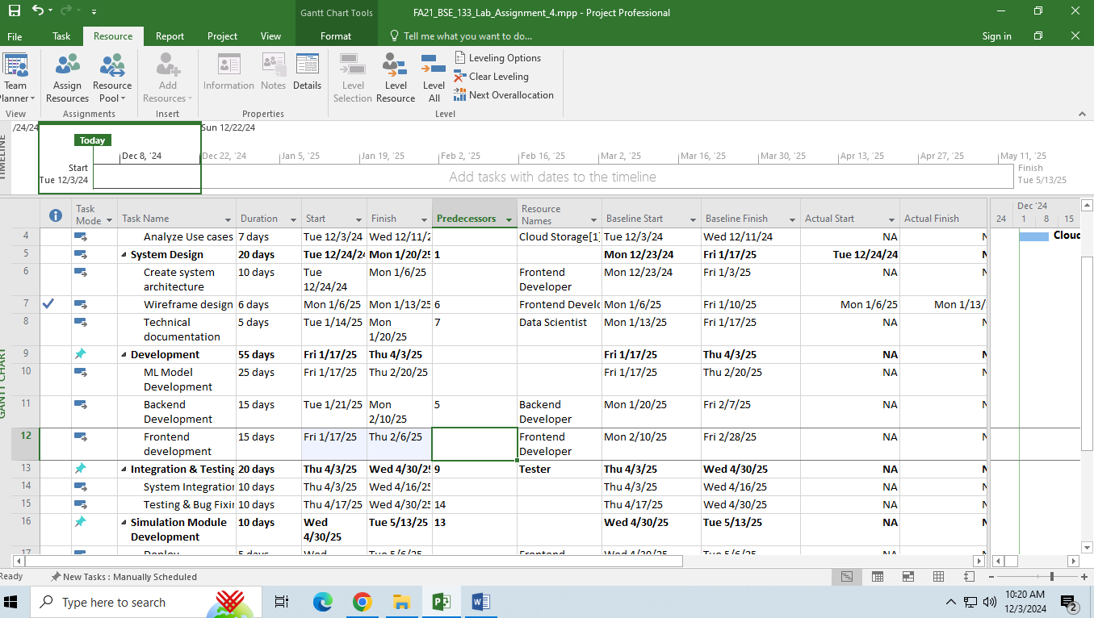

Task 4: Modify start date and observe changes in overall project
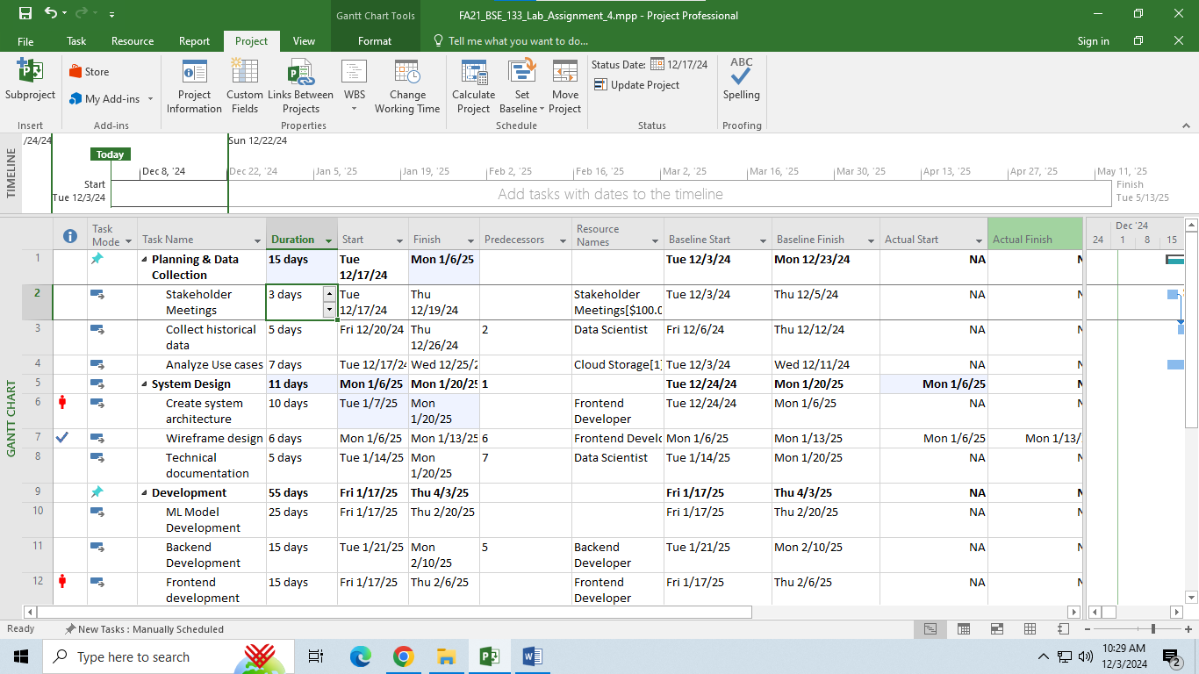

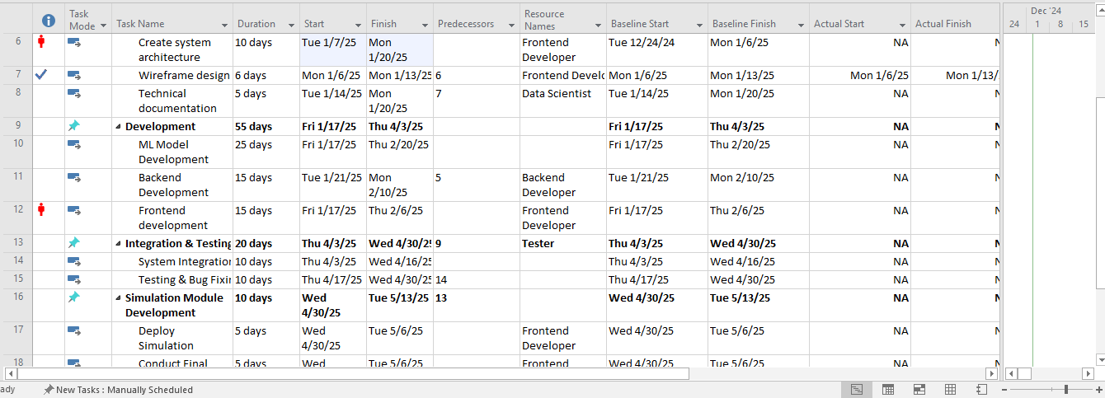

Task 5: Earned value analysis
Interpretation: Cost variance is affected due to a deliverable schedule delay.
